CHAPTER 1
INTRODUCTION

  - PROJECT DESCRIPTION
Lung Cancer Detection Using CNN is an advanced deep learning-based system developed to classify lung cancer conditions into three distinct categories: benign, malignant, and normal. Leveraging the power of Convolutional Neural Networks (CNNs) and high-resolution CT-Scan images, the system is designed to assist in the early and accurate diagnosis of lung cancer.
By automating the analysis of medical images, the system improves diagnostic efficiency and reduces the chances of human error. The CNN architecture is specifically trained to extract meaningful features from lung tissue images, allowing the model to distinguish between cancerous and non-cancerous conditions with high precision.
The project emphasizes scalability, robustness, and clinical relevance, aiming to support medical professionals in decision-making processes. With a simple and intuitive user interface, the system is suitable for deployment in both clinical and research environments. This tool not only supports early diagnosis but also facilitates better patient outcomes by enabling timely medical intervention.

  - COMPANY PROFILE
Accolade Tech Solutions Pvt. Ltd. is a well-regarded software and web development company headquartered in Mangaluru, India. With extensive industry experience, deep technological expertise, and a broad range of services, Accolade Tech Solutions enables clients to enhance their business operations. The company offers comprehensive IT consulting services, guiding organizations on effectively leveraging technology to meet their business goals.

CHAPTER 2
LITERATURE SURVEY

2.1 EXISTING AND PROPOSED SYSTEM
Existing System
Traditional lung cancer detection systems heavily rely on manual image inspection and basic machine learning methods using handcrafted features. These methods often struggle with inconsistent accuracy, time-consuming preprocessing, and limited ability to generalize across different imaging conditions. Such systems require extensive human intervention and domain expertise to interpret CT-Scan images, making the process slower and prone to subjective errors.
Proposed System
The proposed system, Lung Cancer Detection Using CNN, addresses these limitations by leveraging Convolutional Neural Networks (CNNs) to automatically learn features from CT-Scan images. The model uses a deep learning approach to classify images into benign, malignant, or normal categories without manual feature extraction. The system incorporates modern deep learning practices, such as image normalization, multi-layer convolution, and dropout layers to enhance accuracy and generalization. This unified and scalable system improves early diagnosis, reduces human error, and offers faster, more reliable predictions to aid medical professionals.

2.2 FEASIBILITY STUDY
Technical Feasibility
The system uses Convolutional Neural Networks (CNNs) built on frameworks like TensorFlow/Keras, allowing high-accuracy detection of cancerous features in medical images. The application is supported by reliable tools such as PyCharm and Jupyter Notebook, and it is compatible with standard hardware configurations.

Operational Feasibility
The platform provides an intuitive user interface for uploading images and viewing prediction results. It can be operated by healthcare professionals with minimal training. The solution aligns with current clinical workflows and simplifies the diagnostic process.

Economic Feasibility
The use of open-source technologies significantly reduces development and deployment costs. As an AI-powered system, it offers cost-saving benefits by automating routine diagnostic tasks, improving speed, and reducing dependency on manual assessments.
Legal and Ethical Feasibility
The system adheres to standard ethical guidelines in healthcare data usage. It ensures patient confidentiality and follows data privacy norms for medical records. The model only uses anonymized data for training and testing, ensuring legal and ethical compliance.

2.3 TOOLS AND TECHNOLOGIES USED
The Early Detection of Lung Cancer project utilizes a diverse and powerful set of tools and technologies to support development, testing, and deployment. Visual Studio is used for initial code structuring and Windows-based setup, while PyCharm serves as the primary integrated development environment (IDE) for writing and managing Python code related to deep learning. Anaconda Navigator is employed for managing Python environments and launching Jupyter Notebooks, which are instrumental in model development, testing, and data visualization. For backend operations, XAMPP is used to locally manage services such as MySQL, which acts as the database for storing user information, image analysis results, and generated reports. The project leverages TensorFlow and Keras to build and train the convolutional neural network (CNN) model, while Scikit-Learn is used for data preprocessing and evaluation of performance metrics. Additionally, Git and GitHub are implemented for efficient version control and team collaboration throughout the project lifecycle.

CHAPTER 3

SOFTWARE REQUIREMENTS SPECIFICATION

3.1 INTRODUCTION
3.1.1 PURPOSE
The objective of this Software Requirements Specification (SRS) is to formalize and document the client’s vision for the proposed system. This document serves as a detailed blueprint that allows the client to articulate their expectations clearly, ensuring that the development team fully comprehends the necessary features and functionalities required to build the system.
This SRS is intended to guide both developers and testers in the system’s development process. The goals include fully automating the system, minimizing errors, streamlining operations to save time, centralizing database management, enhancing usability for system operators, promoting paperless operations, providing cost-efficient solutions, and delivering an intuitive graphical users interface with context-sensitive help.

3.1.2 DOCUMENT CONVENTIONS/DEFINITIONS AND ABBREVIATIONS
- SRS: Software Requirements Specification
- SVM: Support Vector Machine
- CNN: Convolutional Neural Network
- GUI: Graphical User Interface
- HTTP: Hypertext Transfer Protocol
- DFD: Data Flow Diagram
- SQL: Structured Query Language
- RAM: Random Access Memory

3.1.3 INTENDED AUDIENCE
3.1.3.1 Developers
Developers will use the SRS to guide the implementation of system features and ensure the system aligns with specified requirements throughout development.

3.1.3.2 Administrators
Administrators will manage user access, monitor system data, maintain configuration settings, and ensure the secure and efficient operation of the platform.

3.1.3.3 Doctors
Doctors will use the system to upload CT-Scan images, review diagnostic predictions, download medical reports, and provide informed medical decisions based on AI-generated analysis.

3.1.3.4 Users
Users, such as patients or authorized support staff, can log in to the system to upload reports, check diagnostic status, and communicate with assigned doctors

3.1.4 PROJECT SCOPE:
The SRS defines the requirements for a machine learning-based lung cancer detection system that classifies CT-Scan images as malignant or benign. It will provide features such as secure login, image uploading, AI-based classification, and PDF report generation. The system is intended to improve diagnostic efficiency, accuracy, and accessibility. Administrative capabilities for managing data and maintaining system performance are also included.

3.1.5 BENEFITS
- Early and accurate detection of lung cancer
- Reduced manual diagnostic workload
- Cost-effective and scalable solution
- User-friendly web-based interface
- Reliable prediction and report generation

3.1.6 REFERENCES
- Ian Sommerville, Software Engineering, 5th Edition
- Research papers on Machine Learning in Healthcare
- TensorFlow and Scikit-learn documentation

3.2 OVERALL DESCRIPTION
3.2.1 IDENTIFICATION OF PRE-EXISTING WORK
In the field of lung cancer diagnosis, earlier methods largely depended on manual inspection of CT-Scans by radiologists and semi-automated software systems with hand-crafted feature extraction. These traditional methods were prone to human error, time-consuming, and often failed to scale across large populations or varied image conditions. Early machine learning techniques such as k-NN and Decision Trees improved classification modestly, but still required extensive manual preprocessing and fine-tuning. More recent advancements introduced Support Vector Machines (SVMs) and Convolutional Neural Networks (CNNs), enabling automatic feature learning from high-resolution medical images. While CNNs have shown high accuracy in many image classification tasks, their full potential in clinical diagnostic tools is still being explored. This project builds upon these developments and introduces an integrated system that simplifies image upload, automates cancer detection using SVM or CNN, and provides clinicians with clear diagnostic output and reports. It aims to reduce diagnostic delays, improve consistency, and ensure accessibility to advanced diagnostics.

3.2.2 PRODUCT PERSPECTIVE
The proposed system is designed as a supportive diagnostic tool that complements existing clinical workflows. It offers a web-based interface where authorized users can securely log in, upload CT-Scan images, and receive automated predictions. The backend processes the images using AI algorithms and stores the results in a structured database. Compared to manual systems, this product significantly reduces the time needed for diagnosis and minimizes human error. It integrates modern technologies like Flask, MySQL, TensorFlow, and PDF generation to create a comprehensive, real-time solution. The system's modular design ensures easy maintainability and allows for future scalability. It is particularly suited for integration in hospitals, diagnostic labs, or telemedicine platforms where rapid and reliable diagnostic support is critical

3.2.3 PRODUCT FEATURES
- User Login and Registration: Provides secure access through role-based authentication for users and admins.
- Image Upload: Enables users to upload CT-Scan images in supported formats for processing.
- Cancer Classification: Automatically classifies uploaded images into benign or malignant using AI models.
- Report Generation: Generates downloadable PDF reports including prediction results and patient recommendations.
- Data Management: Stores user details, image metadata, and prediction history in a MySQL database.

3.2.4 END USER CHARACTERISTICS
The system is designed for use by individuals with basic computer literacy. Medical professionals are the primary users who require minimal training to operate the application. The admin users require slightly more technical understanding to manage data and users.

3.2.5 OPERATING ENVIRONMENT
The software will operate on devices with web browsers such as Chrome or Firefox. It requires Python 3.10+, MySQL, and Flask running on a local or cloud server. Basic hardware requirements include a 2.4 GHz processor, 4 GB RAM, and 10 GB free disk space.

3.2.6 DESIGN AND IMPLEMENTATION CONSTRAINTS
The system must support high-resolution CT-Scan images without significant processing delays. All modules must be implemented in Python using open-source libraries. Compatibility across Windows and Linux OS is required. Database design must enforce data integrity and security.
3.2.7 ASSUMPTIONS AND DEPENDENCIES
- Users must be authenticated to use the system.
- Reliable internet access is required for remote server access.
- Python and all required libraries should be installed and configured.
- System assumes valid image data is provided for analysis.

3.3 PRODUCT FUNCTIONALITY
3.3.1 USER MODULE
- Users can register and log into the system securely.
- They can upload CT-Scan images for prediction.
- The system returns a classification (benign or malignant) based on the uploaded image.
- Users can download PDF reports summarizing prediction results.
3.3.2 ADMIN MODULE
- The admin manages doctor and patient user accounts.
- Admins have the ability to add or remove users, update access permissions, and monitor system-wide activity.
- They oversee the system’s data flow and ensure platform security and maintenance.
3.3.3 DOCTOR MODULE
- Doctors can view all patient predictions and access uploaded CT-Scan images.
- They can add medical recommendations or diagnostic notes for each prediction.
- Doctors are able to track patient records over time and download or print reports as needed.

3.4 EXTERNAL INTERFACE REQUIREMENTS
3.4.1 USER INTERFACES
- The system is accessed through a modern web browser with full compatibility across popular platforms.
- The dashboard features a clean layout with dedicated panels for uploading images, viewing prediction results, and downloading PDF reports.
- It includes responsive design elements for usability across devices, along with input validation on login, registration, and file upload forms to ensure secure and correct operation.
- Clear alerts and tooltips assist users in completing each step, enhancing overall usability for patients and doctors alike.
3.4.2 HARDWARE INTERFACES
- Requires a laptop or desktop with a minimum of 2.4 GHz processor and 4 GB RAM.
3.4.3 SOFTWARE INTERFACES
- Built using Flask and Python.
- Interacts with MySQL database.
- Uses libraries like TensorFlow, OpenCV, Scikit-learn, and FPDF.
3.4.4 COMMUNICATION INTERFACES
- Uses HTTP/HTTPS protocols to communicate with the server.
- All transactions between client and server are encrypted using SSL.
3.5 OTHER NON-FUNCTIONAL REQUIREMENTS
3.5.1 PERFORMANCE REQUIREMENTS
- The overall system must provide fast and accurate responses with minimal downtime.
- The application should have built-in error checking and correction mechanisms.
- The application should be able to run efficiently even on basic internet connectivity (minimum 56 kbps bandwidth).
3.5.2 SAFETY REQUIREMENTS
- Only authorized users can access the system after successful login.
- Secure authentication and data protection methods must be enforced.
- User data, especially patient information and medical reports, should be securely encrypted and stored.
3.5.3 SOFTWARE QUALITY ATTRIBUTES

3.5.3.1 Reliability
- The system should provide consistent and accurate results in all operational conditions.
- It should function reliably across different environments and datasets.
3.5.3.2 Maintainability
- The code should be modular and well-documented to support easy upgrades and debugging.
- Maintenance activities should be low-cost and efficient.
3.5.3.3 Portability
- The system should be easily portable across various platforms without extensive reconfiguration.
- Should support standard operating systems and browsers.

3.5.3.4 Usability
- The user interface must be intuitive, easy to navigate, and learnable with minimal training.
- Visual consistency and accessibility standards should be followed.
3.5.3.5 Flexibility
- The system should be easily adaptable to new features or third-party integration.
- Should allow interaction with external APIs and medical tools.

3.6 SPECIFIC REQUIREMENTS
3.6.1 OPERATING ENVIRONMENT
3.6.1.1 Hardware
- Processor: 2.4 GHz or above
- RAM: 4 GB or above
- Hard Disk: 10 GB or more free space
3.6.1.2 Software
- Front End: HTML/CSS/Bootstrap
- Back End: Python (Flask Framework)
- Database: MySQL

3.7 DELIVERY PLAN
- The system should fulfill all client requirements as outlined in the SRS.
- Each module must pass functionality and performance tests.
- Final delivery should include complete documentation, tested codebase, and deployment instructions.

CHAPTER 4

SYSTEM DESIGN

4.1SYSTEM DESIGN
4.1.1INTRODUCTION
A primary phase of the software developments is a system design. It aims in identifying the modules that has to be in the system, the specification of these modules and how they interact with each other to produce the desired result. During the system design user requirements are translated into system characteristics. It includes logical design as well as physical construction of the system. The logical design describes the input files, output files and databases, all in a matter that must meet the project requirements. It improves the understanding and procedural details necessary for implementing the new system.

4.1.2 SCOPE OF THE PROJECT
- Early Detection through AI/ML: The system will leverage artificial intelligence or machine learning models to analyze patient data and detect early signs of lung cancer with high accuracy.
- Medical Record Management: Maintain detailed electronic records of patients, including reports, scans, and prediction results for future reference and treatment planning.
- Risk Prediction: Enable the system to predict the likelihood of lung cancer based on various risk factors such as age, family history, genetic information, and other medical conditions.
- Doctor-Patient Interaction: Facilitate communication between doctors and patients for consultations, recommendations, and follow-up appointments through the platform.
- Admin Control Panel: Provide administrative features for managing users (patients and doctors), reviewing prediction logs, and overseeing system operations.
- User-Friendly Interface: Ensure that the system is accessible and easy to use for both medical professionals and patients with minimal technical knowledge.

- Data Security & Privacy: Implement strong authentication and encryption to secure patient data in compliance with health data protection standards.
- Scalability & Integration: Design the system in a way that it can be integrated with existing hospital or clinic systems and scaled for larger user bases or additional diagnostic features.

4.1.3 INTENDED AUDIENCE
The intended users of the Lung Cancer Detection System are the key stakeholders who interact with the application to perform specific roles that contribute to early diagnosis and medical decision-making. This system is designed to serve three primary user groups: Admins, Doctors, and Patients. Each user plays a distinct role in ensuring the effectiveness of the system
Admin
- Manage system operations, oversee user accounts, and maintain data integrity.
- Monitor model performance and ensure compliance with data policies.
Doctor
- Access patient history and diagnostic predictions.
- Analyze AI-generated reports and guide patients accordingly.
- Input clinical data and review past consultations.
Patient
- Register and update personal medical information.
- Submit diagnostic data for early detection analysis.
- View prediction results and consult with doctors through the system.

4.1.4 CONTEXT FLOW DIAGRAM

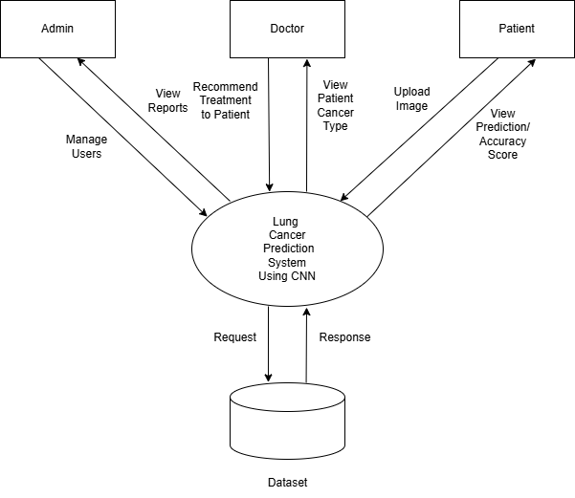

4.1.5 DATA FLOW DIAGRAM

4.1.5.1 ADMIN DFD

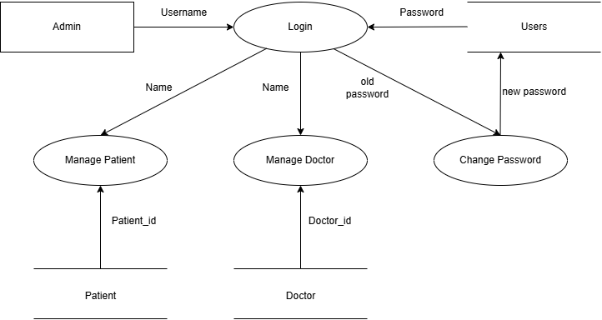
4.1.5.2 DOCTOR DFD
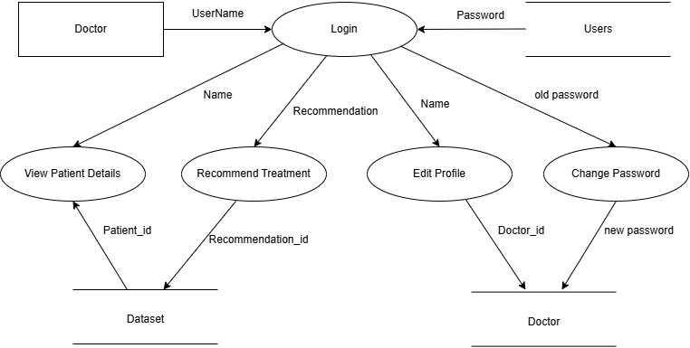

4.1.5.3 PATIENT DFD
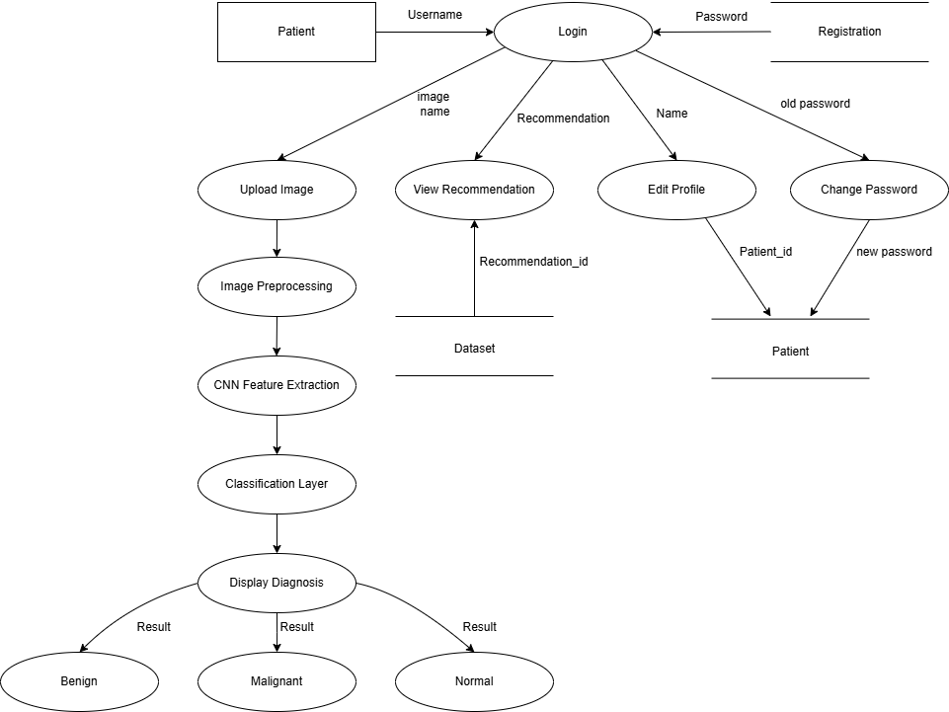

4.2 DETAILED DESIGN

4.2.1 USECASE DIAGRAM
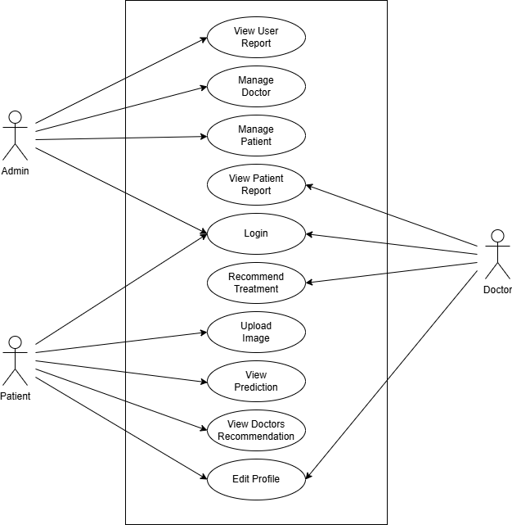

4.2.2 SEQUENCE DIAGRAM
4.2.2.1 ADMIN

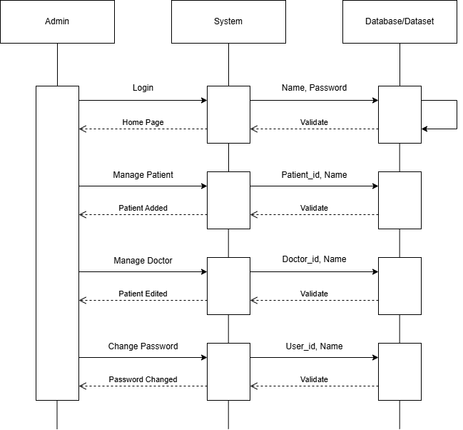

4.2.2.2 DOCTOR
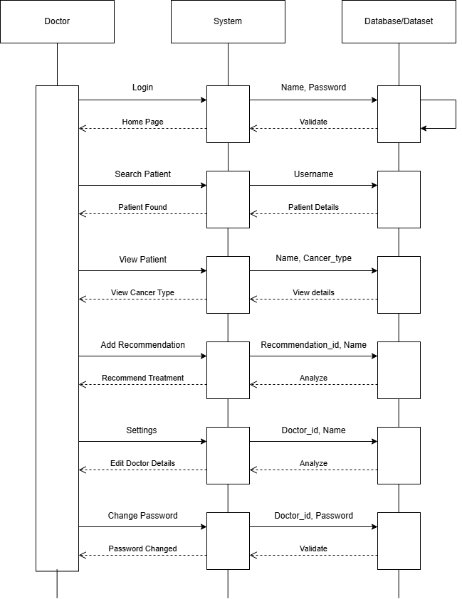
4.2.2.3 PATIENT
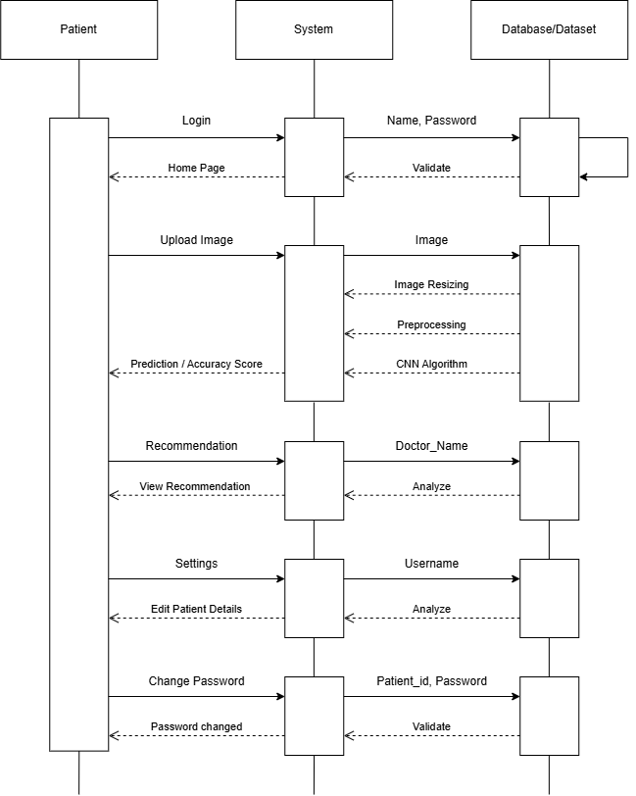

4.2.3 ACTIVITY DIAGRAM
4.2.3.1 ADMIN

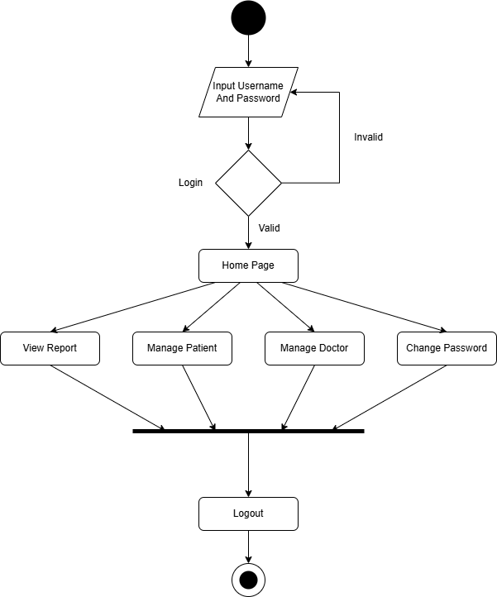
4.2.3.2 DOCTOR
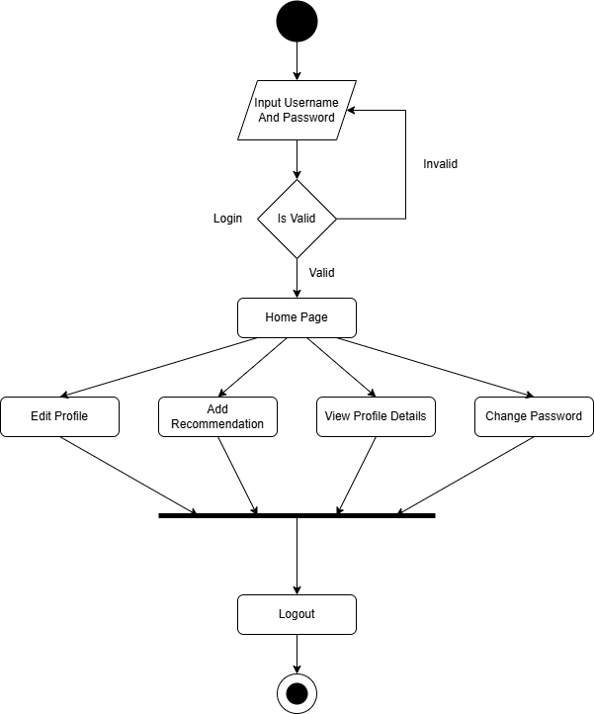

4.2.3.3 PATIENT

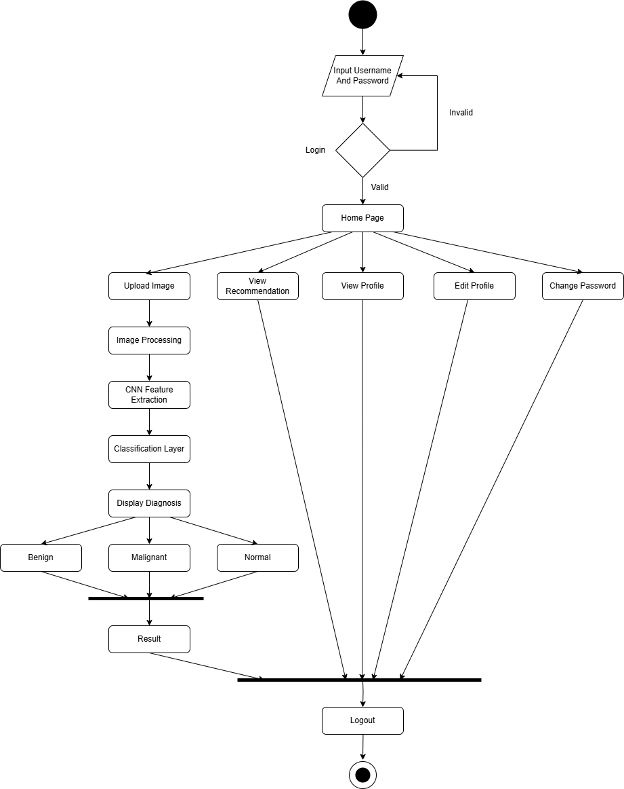

4.3 DATABASE DESIGN

4.3.1 USERS
Attribute | Data Type | Constraints | Description
user_id | INT(11) | PRIMARY KEY, AUTO_INCREMENT | Unique identifier for each user
username | VARCHAR(50) | NOT NULL | Full name of the user
email | VARCHAR(50) | NOT NULL, UNIQUE | User's login email
password | VARCHAR(255) | NOT NULL | Hashed password
role | ENUM | ('patient', 'doctor', 'admin'), NOT NULL | Role assigned to the user
created_at | TIMESTAMP | DEFAULT CURRENT_TIMESTAMP | Account creation timestamp

4.3.2 ADMINS
Attribute | Data Type | Constraints | Description
admin_id | INT(11) | PRIMARY KEY, AUTO_INCREMENT | Unique identifier for admin
user_id | INT(11) | FOREIGN KEY (users.user_id) | Associated user ID
admin_name | VARCHAR(50) | NOT NULL | Admin’s full name
phone | VARCHAR(15) | NOT NULL | Admin’s contact number
address | VARCHAR(100) | NOT NULL | Admin’s address

4.3.3 DOCTORS
Attribute | Data Type | Constraints | Description
doctor_id | INT(11) | PRIMARY KEY, AUTO_INCREMENT | Unique identifier for each doctor
user_id | INT(11) | FOREIGN KEY (users.user_id) | Linked user ID
doctor_name | VARCHAR(50) | NOT NULL | Full name of the doctor
speciality | VARCHAR(50) | NOT NULL | Doctor’s specialization (e.g., Oncologist)
phone | VARCHAR(15) | NOT NULL | Doctor’s contact number
address | VARCHAR(100) | NOT NULL | Clinic or residence address
gender | ENUM | ('Male','Female','Other'), NOT NULL | Gender of the doctor

4.3.4 PATIENTS
Attribute | Data Type | Constraints | Description
patient_id | INT(11) | PRIMARY KEY, AUTO_INCREMENT | Unique patient identifier
user_id | INT(11) | FOREIGN KEY (users.user_id) | Linked user ID
patient_name | VARCHAR(50) | NOT NULL | Full name of the patient
dob | DATE | NOT NULL | Date of birth
gender | ENUM | ('Male','Female','Other'), NOT NULL | Gender of the patient
phone | VARCHAR(15) | NOT NULL | Contact number
address | VARCHAR(100) | NOT NULL | Patient’s residential address
blood_type | VARCHAR(10) | NOT NULL | Blood group

4.3.5 PREDICTIONS
Attribute | Data Type | Constraints | Description
prediction_id | INT(11) | PRIMARY KEY, AUTO_INCREMENT | Unique ID for prediction
user_id | INT(11) | FOREIGN KEY (users.user_id) | User associated with the prediction
filename | VARCHAR(100) | NOT NULL | File name of the uploaded CT-Scan image
predicted_class | VARCHAR(50) | NOT NULL | Output class (e.g., benign, malignant, normal)
confidence_scores | TEXT | NOT NULL | JSON-formatted confidence probabilities
image_path | VARCHAR(255) | NOT NULL | Path to the stored image
recommendation | TEXT | NULLABLE | Doctor’s comment or advice based on the prediction
timestamp | TIMESTAMP | DEFAULT CURRENT_TIMESTAMP | Date and time of prediction

CHAPTER 5:
IMPLEMENTATION
5.1 INTRODUCTION
Implementation is the process of executing a plan. It involves an overview, a brief description, and the tasks required to carry out the implementation. During this phase, various test cases are evaluated and integrated into the system.
Adhering to coding standards is crucial because it ensures that the code is organized and comprehensible, even to those who are not the original developers. This facilitates easier maintenance, as others can modify or upgrade the system if needed. The naming conventions used are consistent with those of Windows classes.
5.2 PSEUDO CODE
5.2.1 PSEUDO CODE FOR REGISTRATION PAGE:
Users must register with the system by providing their name, email ID, contact number, password, and confirming the password. If the provided data is valid, a message will display: "Registration successful."
Begin
Input: Name, Email ID, Contact Number, Password, Confirm Password
Verify that all mandatory fields are filled and the data is valid.
If the data is valid:
Update the database
Display "Registration successful"
Else:
Show an error message
End
5.2.2 PSEUDO CODE FOR LOGIN PAGE
Users must log in with their username and password. If the username is found, verify if the password matches. If the password is correct, the login is successful; otherwise, an error message will be displayed.
Begin
Input: Email, Password
Validate that both fields are filled and the data is correct.
If the Email and Password are valid:
Call check User Type()
If the user type is admin:
Navigate to Dashboard()
Else if:
Navigate to Home()
Else:
Display an error message
End

5.2.3 PSEUDO CODE FOR LUNG CANCER DETECTION
Begin
Input: High-resolution CT-Scan images
Preprocess the images:
Apply normalization
Perform noise reduction
Apply contrast enhancement
Standardize image size and resolution
Extract features:
Identify texture, shape, density, and cancer size
Analyze features using Convolutional Neural Network (CNN):
Classify cancer as benign or malignant based on trained dataset
If cancer is malignant:
Recommend further medical evaluations and treatment
Else if cancer is benign:
Suggest routine monitoring and preventive measures
End

5.2.4 CNN ALGORITHM DETAILS
To classify lung CT scan images into three categories — Benign, Malignant, and Normal — we developed a Convolutional Neural Network (CNN) using TensorFlow/Keras. The model architecture begins with a convolutional layer consisting of 32 filters of size 3x3 with ReLU activation, followed by a 2x2 max pooling layer to reduce spatial dimensions. A second convolutional layer with 64 filters and another 2x2 max pooling layer further extracts deeper features. The output is then flattened and passed through a fully connected dense layer with 128 neurons and ReLU activation, followed by a dropout layer with a rate of 0.5 to prevent overfitting. The final output layer uses a softmax activation function with 3 neurons, corresponding to the three target classes. The model is compiled using the Adam optimizer and trained with the sparse_categorical_crossentropy loss function, suitable for integer-labeled multi-class classification. It was trained over 15 epochs with a batch size of 32, using an 80-20 train-validation split. This architecture efficiently captures spatial patterns in medical images and provides robust classification performance.
5.2.5 ACCURACY ASSESSMENT
To evaluate the trained CNN model on new CT scan images, we implemented a prediction function that processes input images and outputs the predicted class along with the confidence level. The input image is first read using OpenCV, converted from BGR to RGB format, resized to 224×224 pixels to match the model's input dimensions, and normalized to the [0, 1] range. The processed image is then reshaped into a 4D array of shape (1, 224, 224, 3) and passed to the trained model for prediction. The model outputs a probability distribution over the three target classes — Benign, Malignant, and Normal — using the softmax activation function in the final layer. To determine the most likely class, we use the argmax() function, which returns the index of the highest probability, corresponding to the predicted class. The associated maximum probability, obtained using np.max(), reflects the model’s confidence in its prediction. This approach provides a straightforward yet effective way to interpret the model’s output by mapping numerical results back to human-readable class labels, and visually displaying the prediction along with confidence percentage and the input image.

CHAPTER 6
SOFTWARE TESTING
6.1 INTRODUCTION
Testing is an essential process designed to ensure the correctness, completeness, and quality of software. It plays a critical role in the success of a system by identifying and addressing software failures. The primary goal of testing is to uncover defects so they can be resolved. This project is evaluated against specified user requirements through various validations and tests to ensure those needs are met. Testing occurs at both the unit and integration levels, and the system is also assessed by users unfamiliar with the software to determine if it meets expected outcomes. The testing process involves defining test conditions, generating test data, and creating a schedule of expected versus actual results. Initially, individual units are tested, followed by comprehensive testing of the entire system.

6.2 TESTING OBJECTIVES
- Ensure the software meets the user's requirements and is designed accordingly.
- Improve software quality and ensure the product is error-free.
- Verify that all necessary validation and verification processes are completed.
- Confirm that all modules are implemented as per the requirements.
The testing for this project includes Unit Testing, Integration Testing, Functional Testing, and Regression Testing. The implementation details for each module are outlined below.

6.3 UNIT TESTING
Unit testing, also known as component testing, involves evaluating specific sections of code, typically at the functional level. These tests are usually conducted by developers or programmers during the coding phase to verify that each function performs as expected. Unit testing is vital for preventing and detecting defects, thus helping to mitigate risks, reduce development time, and lower costs. The primary aim of unit testing is to validate that each software unit operates as intended. A unit is the smallest testable component of the software, generally having one or a few inputs and a single output.

6.3.1 UNIT TEST CASES
Unit testing involves evaluating the smallest testable components of an application. Identifying and fixing errors at this stage is straightforward, efficient, and cost-effective. In this project, each module is tested individually with suitable inputs to verify that it produces the expected outputs.

6.3.2 TESTING FOR VALID USER NAME
Test case | Input | Test description | Output
1 | Already exists username | User name cannot repetitive | User named previously exist
2 | User name is left blank | User name cannot be left blank | Must Enter user name
Table 6.3.2 Testing for valid user name

6.3.3 TESTING FOR VALID PASSWORD
Test case | Input | Test description | Output
1 | Password is left blank | Password cannot be blank | Must Enter password
2 | Invalid password entered | Valid password must be entered | Password  mismatch
Tabled 6.3.3 testing for valid password

6.3.4 TESTING FOR DATA INSERTION
Test case | Input | Test description | Output
1 | Mandatory fields left empty | Mandatory fields cannot be left empty | Must enter data
2 | Duplicate entry | Duplicate entry not allowed | Appropriate error message
3 | Input without above faults | Valid input | Record inserted Successfully
Table 6.3.4 Testing for data insertion

6.3.5 TESTING FOR REGISTRATION
Tests case | Inputs | Tests descriptions | Output
1 | If any field left blank | All values must be entered. | All values must be entered.
2 | Username is Text | Valid username need to be entered | Enter correct username
4 | If Password is blank | Password is empty | Enter password
5 | Confirm password  does not match | Password does not match | Password mismatch
6 | Valid input | Valid input | Registrations successful
Table 6.3.5 Testing for registration

6.3.6 TESTING FOR DATA
Test case | Input | Test description | Output
1 | Image | Data should be in JPEG/JPG/PNG format. | Data will be fetched
2 | Image | Invalid format | Error is thrown
Table 6.3.6 Testing for data

6.3.7 TESTINGS FOR ANALYSIS
Tests case | Input | Test description | Output
1 | analysis | The Model should be loaded | If not proper model not selected it may throw any error
Table 6.3.7 Testing for Analysis

6.3.8 TESTING FOR FORM
Test case | Input | Test description | Output
1 | form | All values must be entered. | An error will be thrown if it is not selected.
Table 6.3.8 Testing for Form

6.4 INTERGRATION TESTING
Integration testing is a software testing approach focused on verifying the interactions and interfaces between components according to the software design. In this project, integration testing is advantageous because it helps to quickly identify and isolate interface issues. It aims to uncover defects in the interactions between integrated modules. As testing progresses, increasingly larger groups of tested components aligned with the architectural design are integrated and tested until the entire software functions as a cohesive system.

6.4.1 INTEGRATION TEST CASES
Combining modules in an application can have a negative effect on the other and could produce undesirable outcomes. As a result, every module in this project is integrated and tested as a whole.

No | Test cases | Expected Output | Observed Output | Result
1 | Required  fields are not filled out | Mandatory fields  must not be left blank | Displays an  error message as expected | Pass
2 | A duplicate entry is provided | Duplicate entries should be disallowed | Displays an error message as expected | Pass
6.4.1 Integration Test Cases for Data Insertion

6.4.2 OTHER CASES:
Test case | Input | Test description | Output
1 | Click on exit | The application will close | Application closes
2 | Click on clear | While entering details | The record is not submitted to the database, and text fields are cleared
3 | Click on save | After entering details | The record is submitted to the database
4 | Click on save | Without entering  details | An appropriate error message is displayed
5 | 6789 | Typing numbers in the field of letter | No characters will be  displayed
6 | Click on Drop  Down list | Selecting data | Data is displayed

CHAPTER 7
SCREENSHOTS
REGISTRATION PAGE
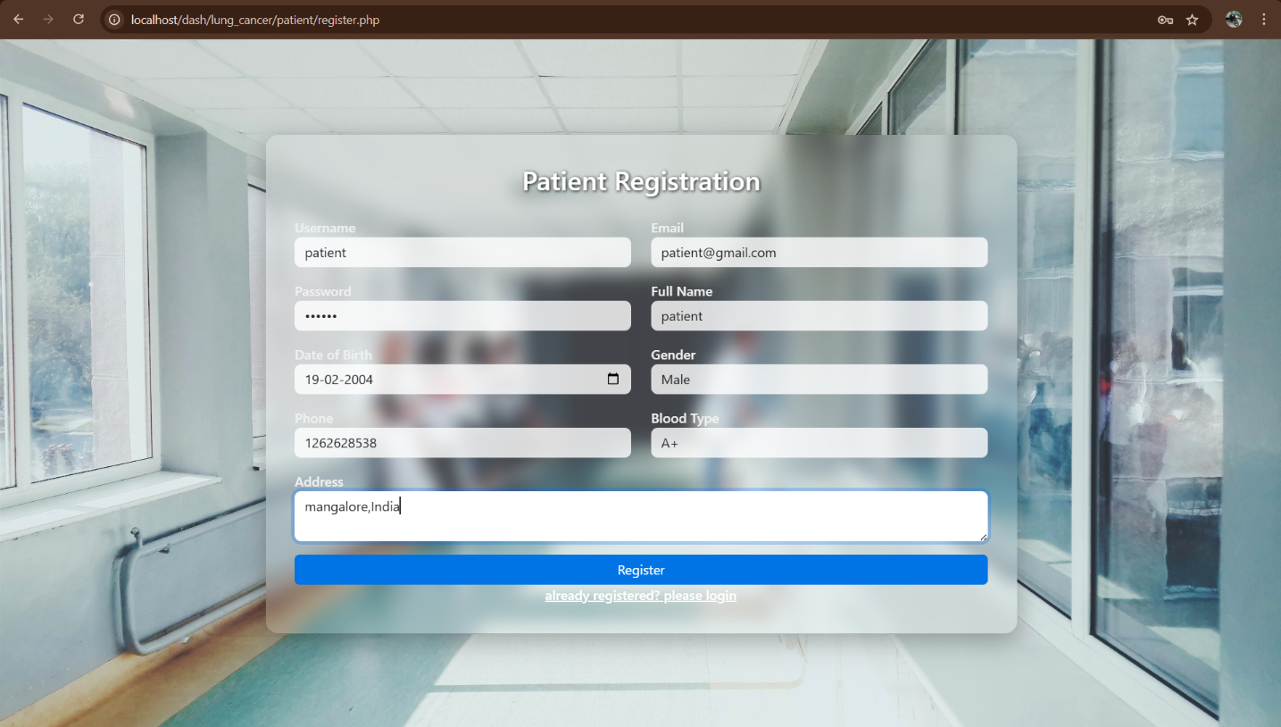
LOGIN PAGE
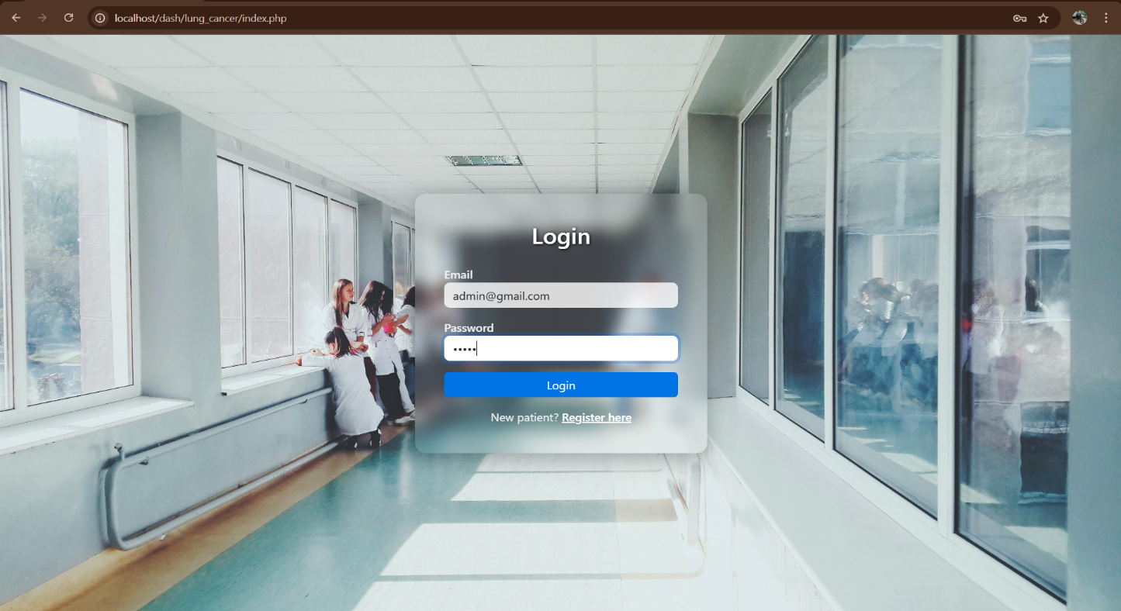
LOGIN ERROR
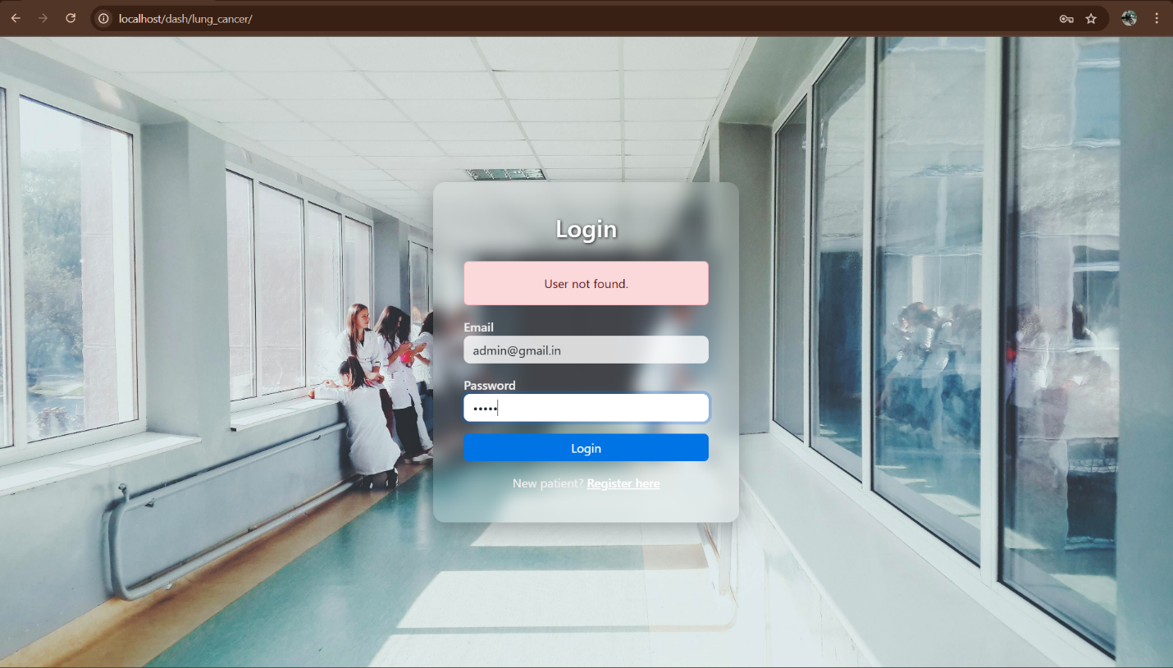

ADMIN DASHBOARD
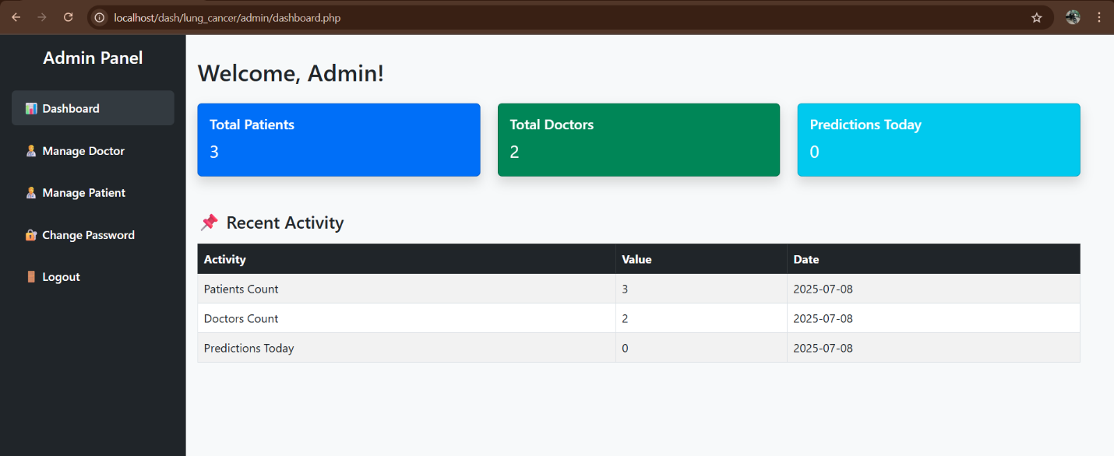

MANAGE DOCTOR
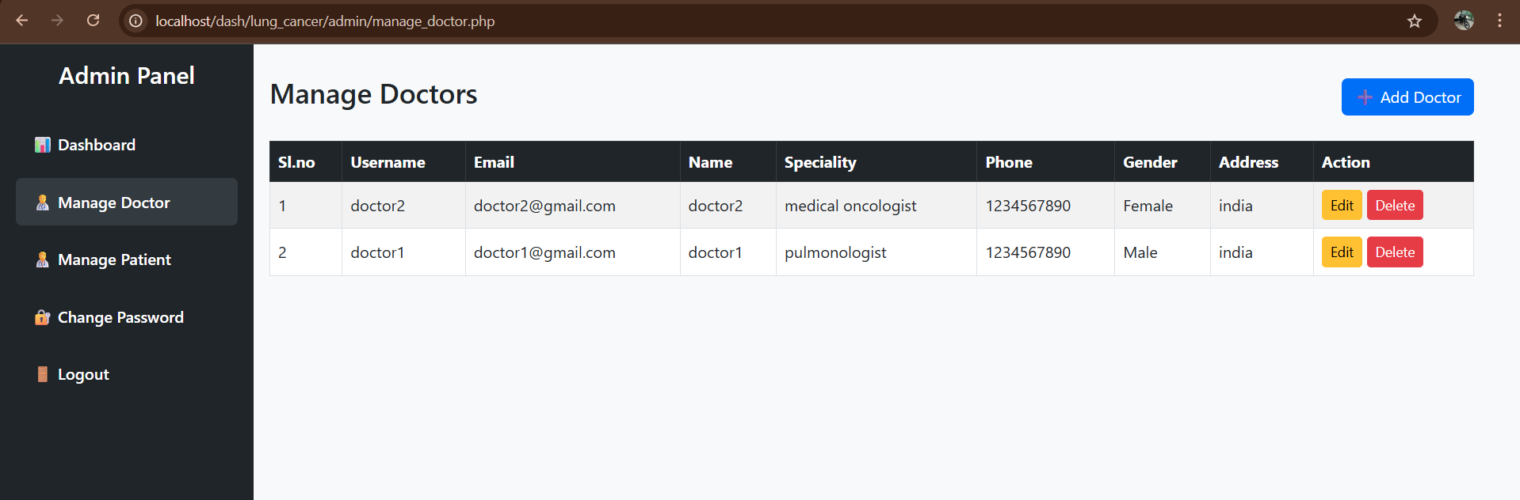

ADD NEW DOCTOR
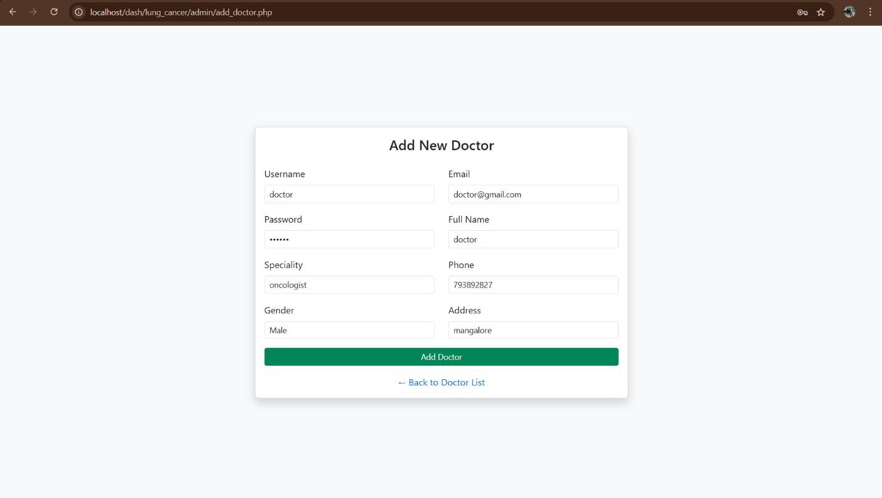

EDIT DOCTOR
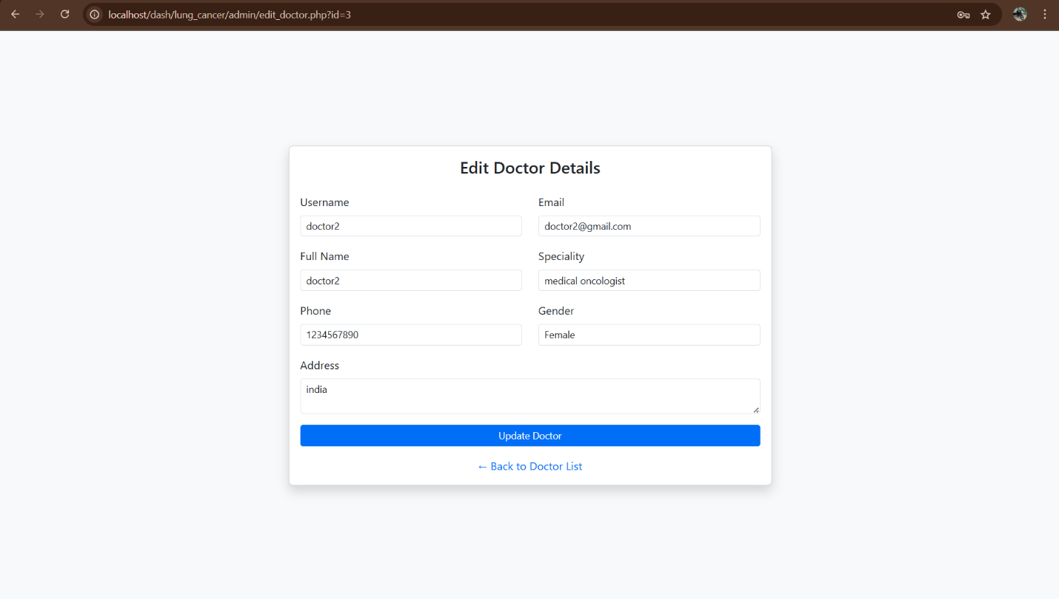

MANAGE PATIENT
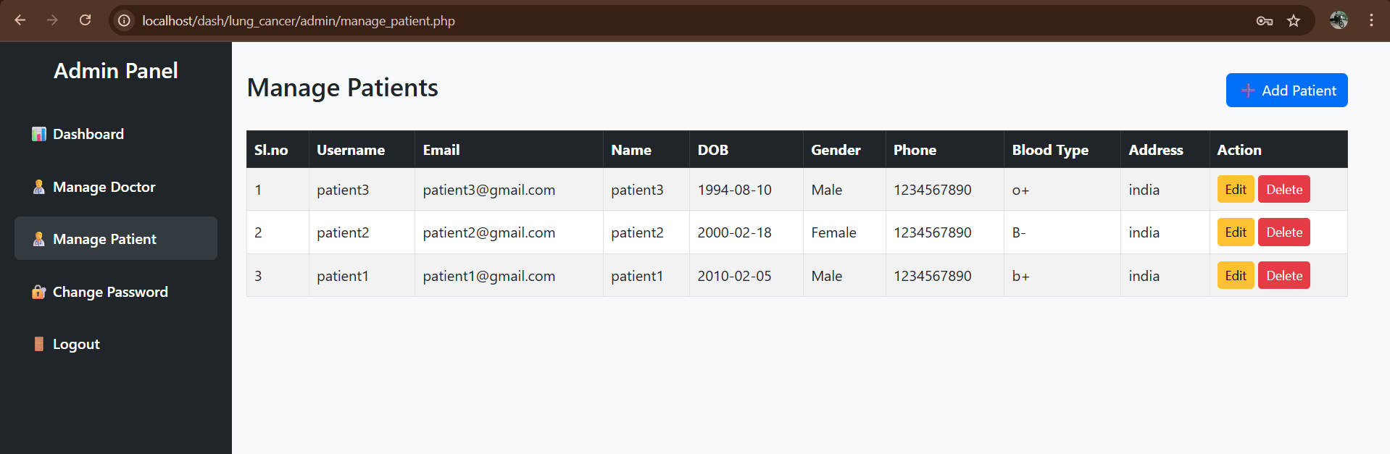

ADD NEW PATIENT
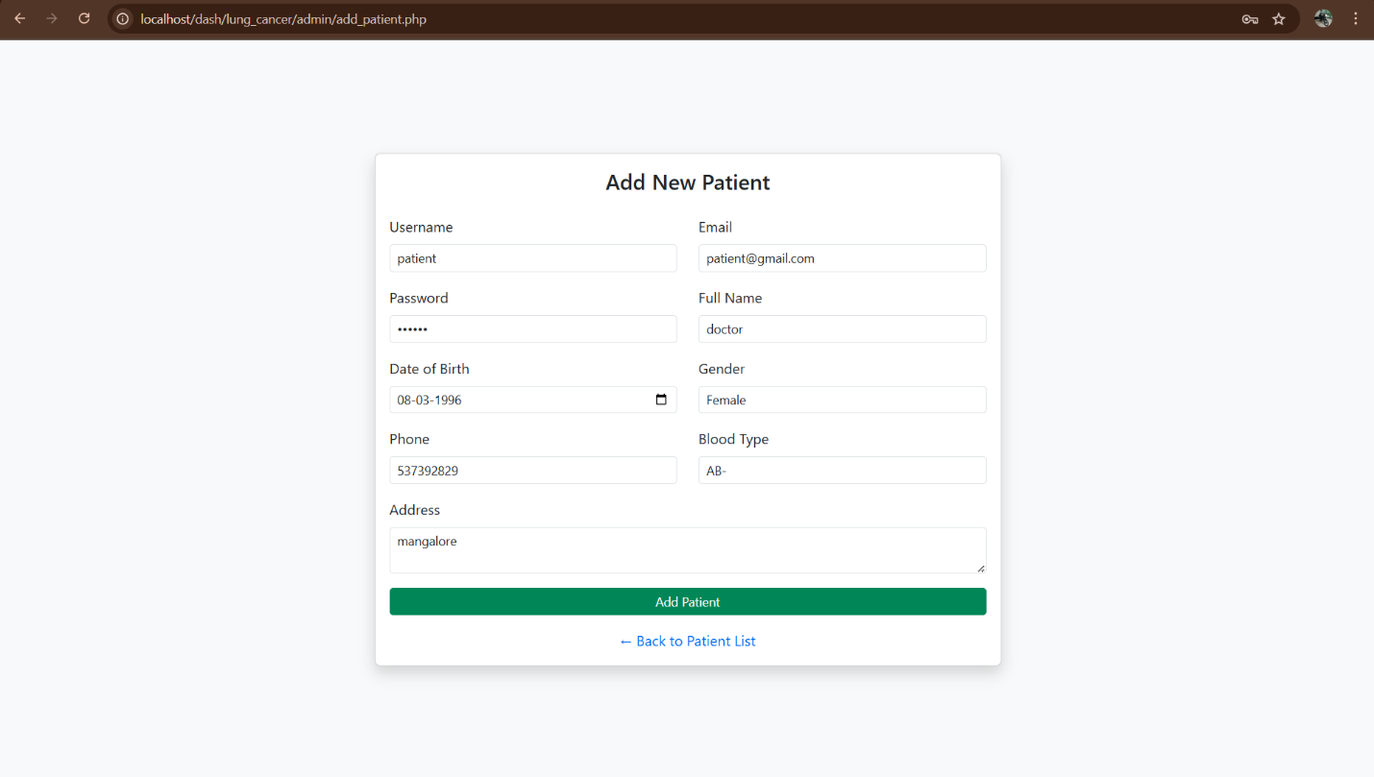

EDIT PATIENT
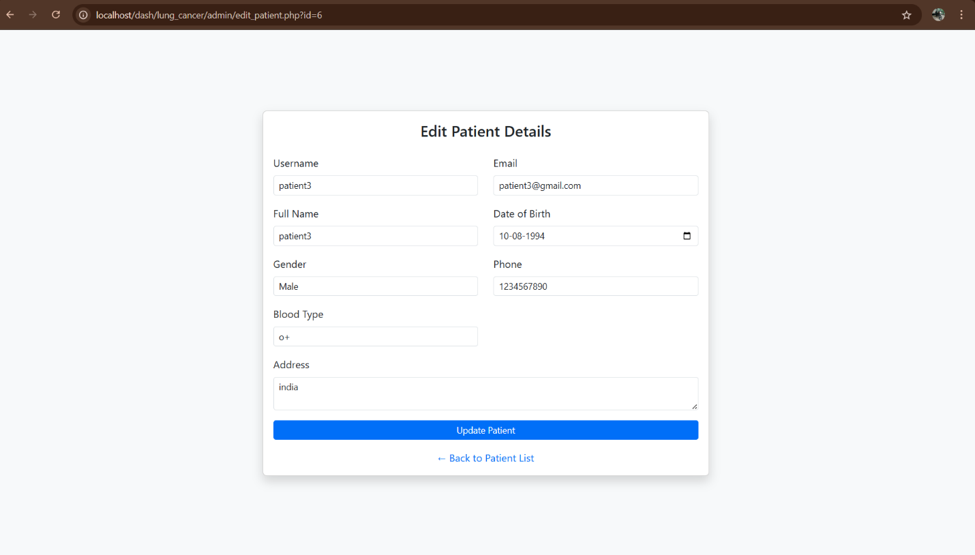
CHANGE PASSWORD
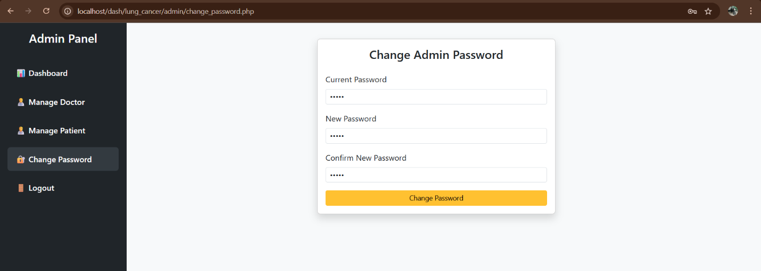

DOCTOR DASHBOARD
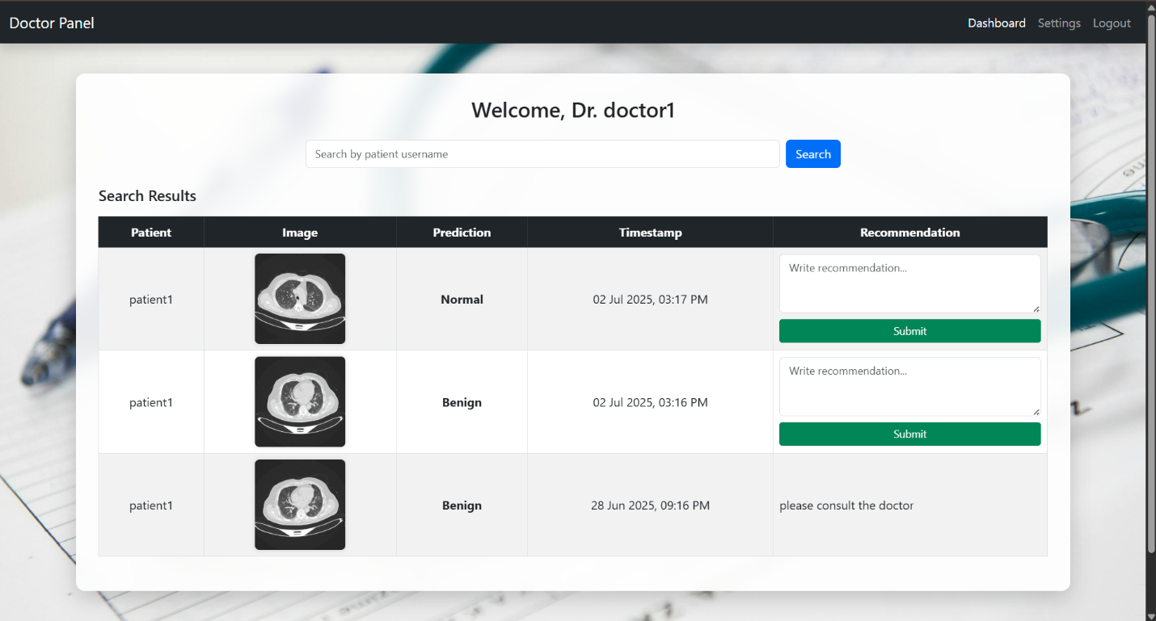

DOCTOR SETTINGS
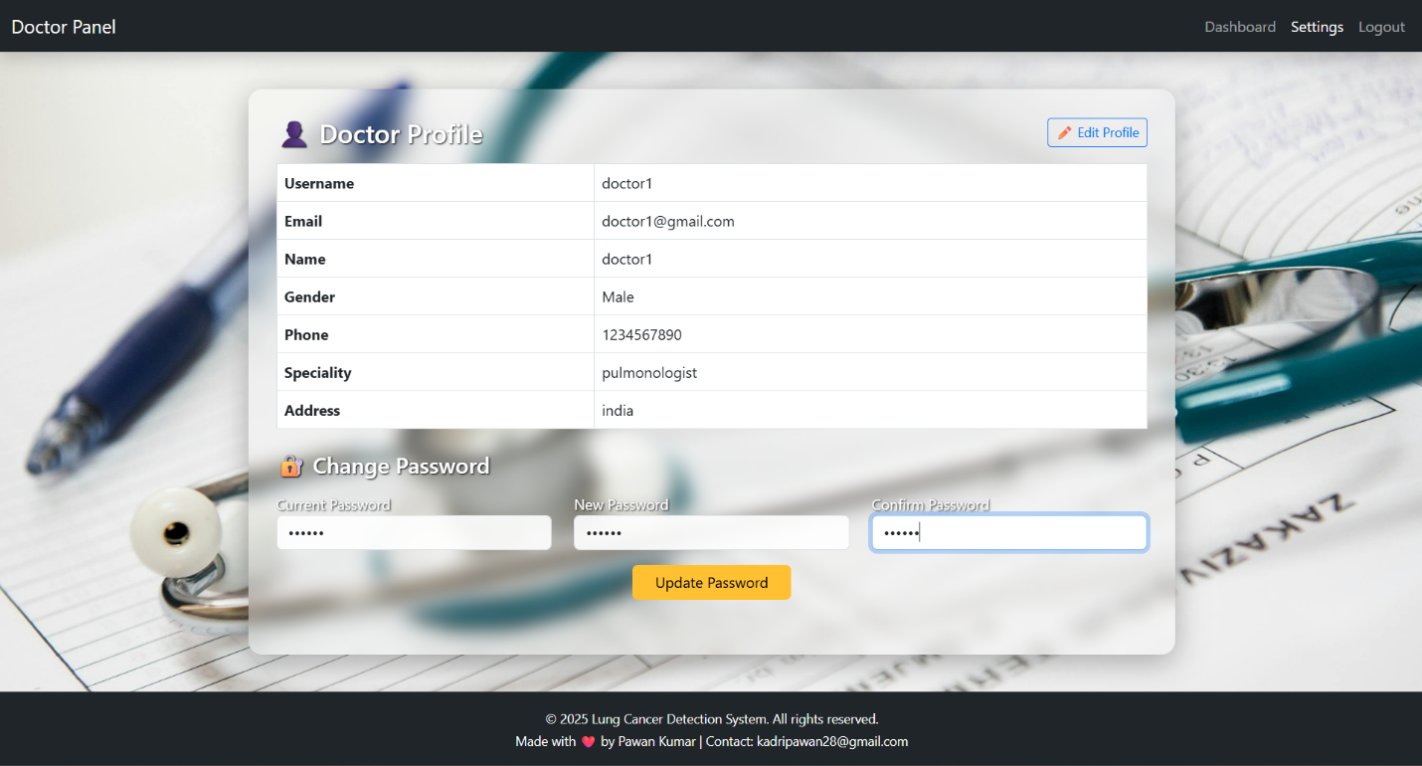

EDIT PROFILE
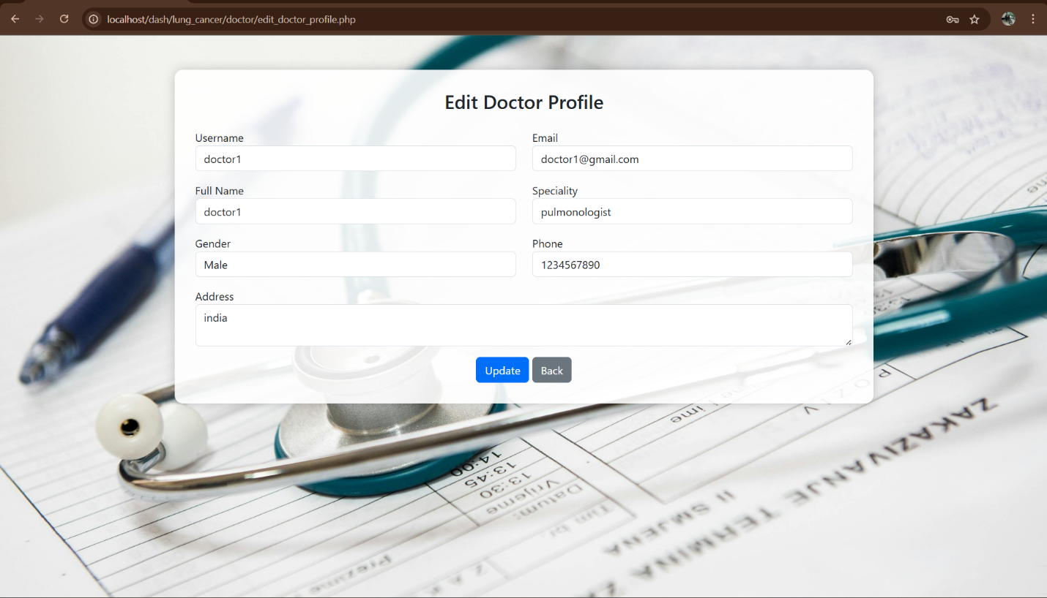

PATIENT DASHBOARD
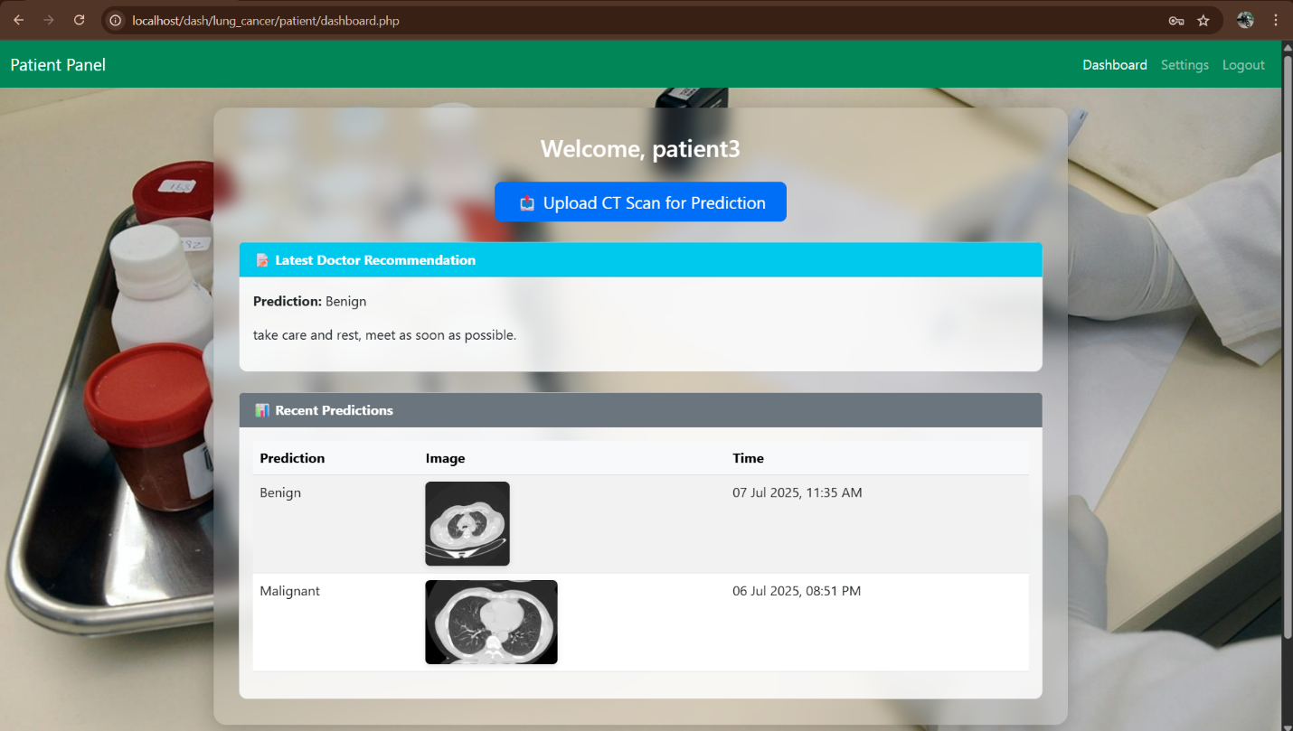

PATIENT PREDICTION
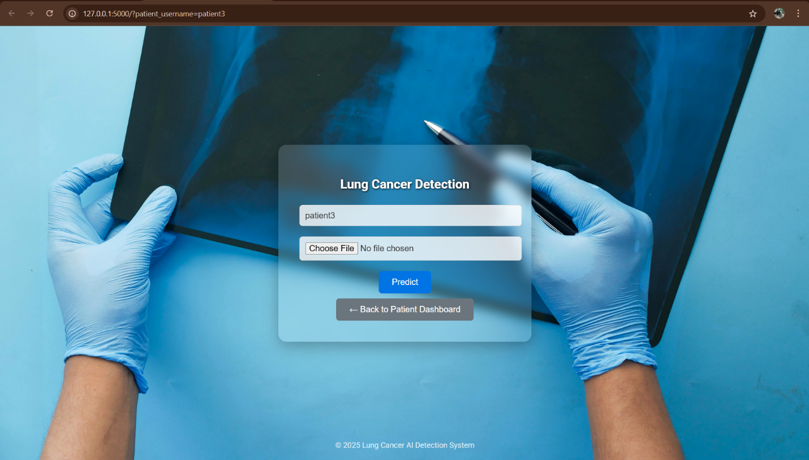
BENIGN CASE PREDICTION RESULT
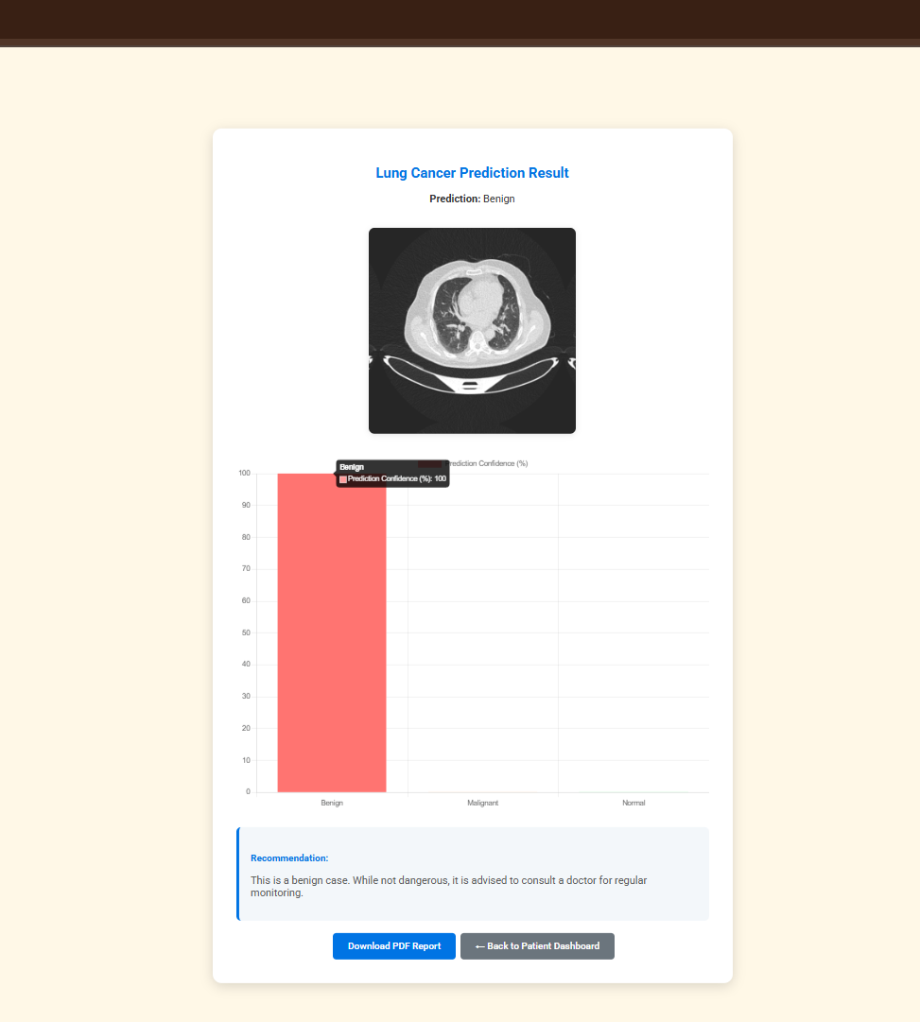

MALIGNANT CASE PREDICTION RESULT
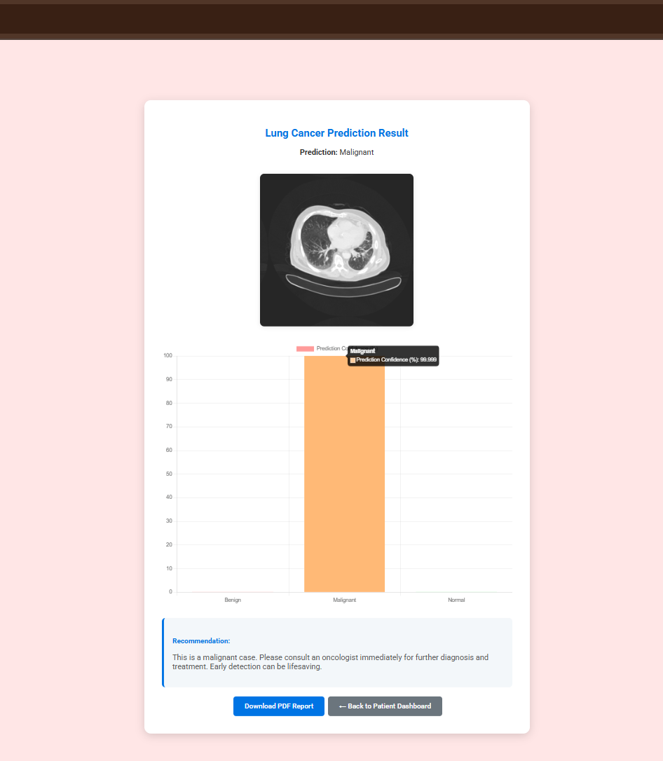

NORMAL CASE PREDICTION RESULT
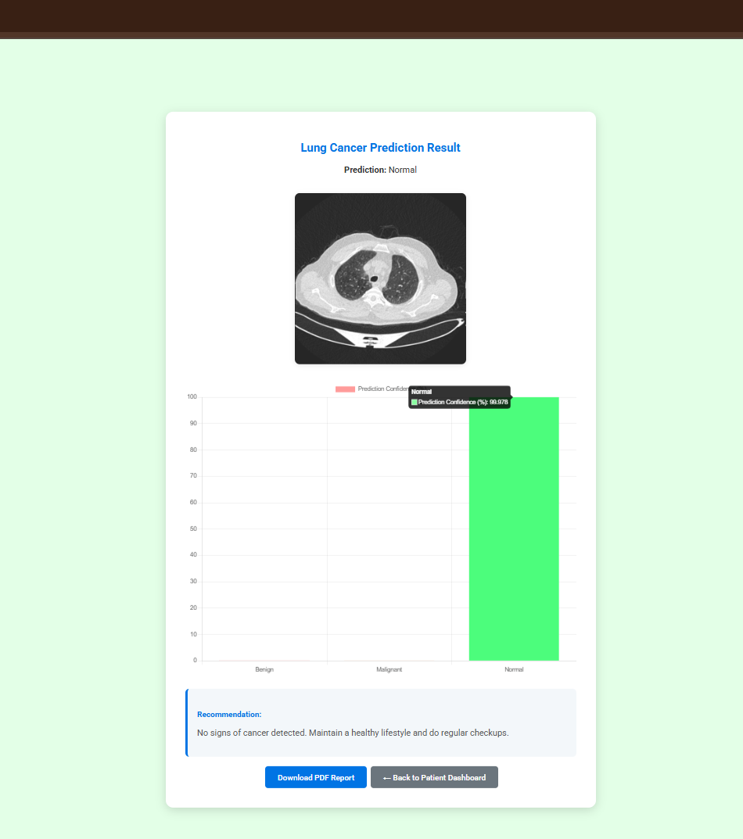

PATIENT SETTINGS
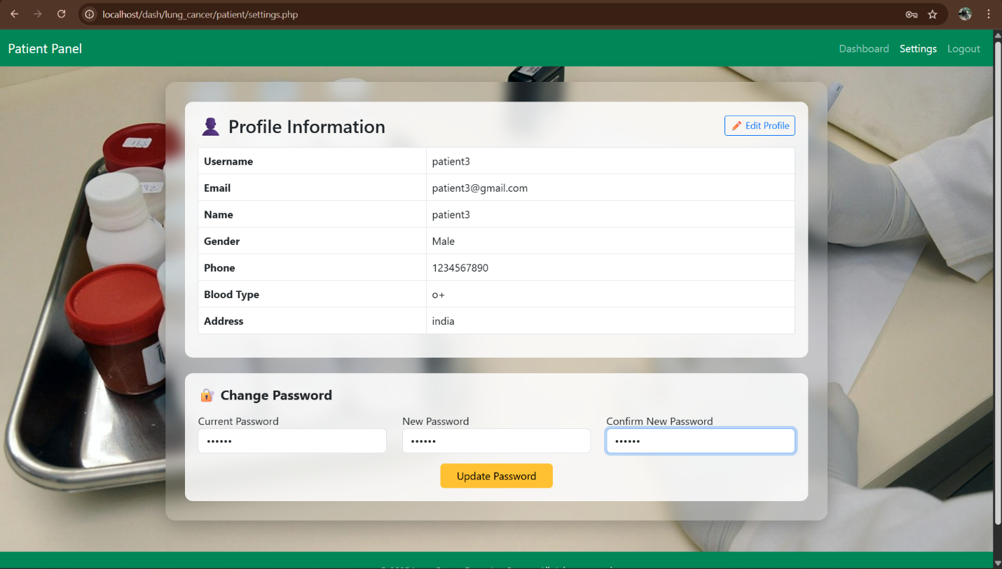

EDIT PROFILE
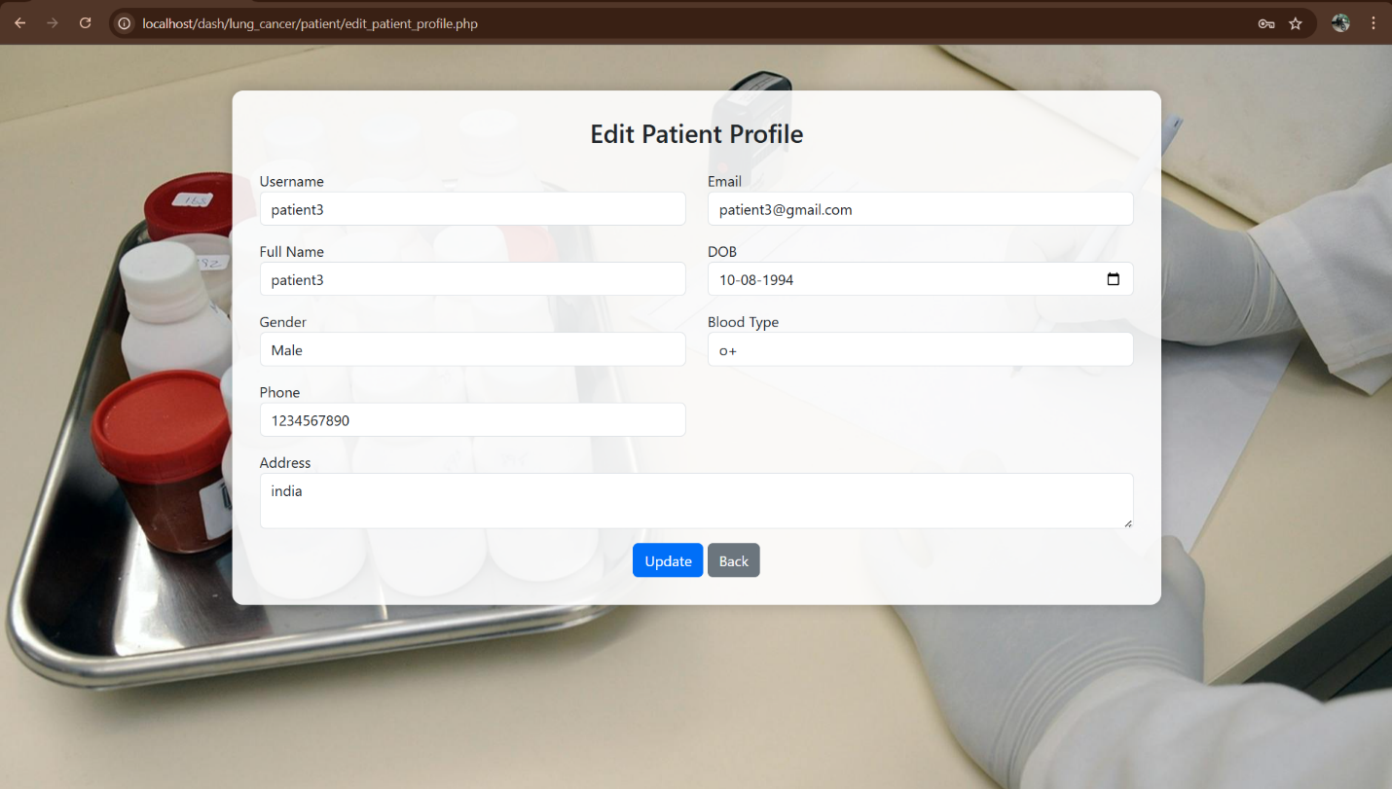
CHAPTER 8
CONCLUSION

The Early Detection of Lung Cancer using Convolutional Neural Networks (CNNs) project represents a major step forward in the medical diagnostics domain by leveraging state-of-the-art deep learning techniques to address the critical challenge of classifying CT-Scan images into benign, malignant, and normal categories. Through the development and implementation of powerful CNN-based models, the system effectively overcomes the limitations of traditional manual inspection and rule-based methods, delivering a scalable and highly accurate solution for early lung cancer detection.
By integrating intuitive user interfaces and ensuring consistent performance across diverse image datasets, the system enhances the diagnostic experience for patients, doctors, and healthcare administrators alike. The project’s innovative architecture, including the use of automated preprocessing, real-time prediction, and structured reporting, ensures both usability and reliability in clinical environments.
Overall, this system not only aids in early diagnosis but also sets a precedent for future AI-assisted medical tools. It serves as a testament to how technology and healthcare can combine to provide life-saving support, ensuring quicker decisions and more efficient patient management in the fight against lung cancer.

CHAPTER 9
FUTURE ENHANCEMENTS

Future enhancements for the Early Detection of Lung Cancer system could include support for real-time image analysis and integration with live imaging devices such as portable ultrasound or IoT-enabled mammography equipment. The system can be extended to provide multilingual support for better accessibility across different regions and healthcare environments.
Implementing more advanced machine learning models, such as ensemble learning or transformer-based architectures, could further improve classification accuracy and interpretability. Additionally, a collaborative portal where doctors can share insights, annotate cases, and contribute to a centralized diagnostic repository would enhance medical collaboration.
Incorporating patient feedback tools and automated follow-up notifications could also improve post-diagnosis care. Continuously updating the model using recent datasets and aligning with global diagnostic standards will ensure the system evolves and maintains high accuracy and relevance in clinical practice.

CHAPTER 10

REFERENCES
[1] Ian Sommerville, Software Engineering, 5th Edition, Addison-Wesley, 1995.
[2] Krizhevsky, A., Sutskever, I., & Hinton, G. E., "ImageNet Classification with Deep Convolutional Neural Networks," Communications of the ACM, 2017, 60(6), pp. 84-90. DOI: 10.1145/3065386
[3] American Cancer Society, "Lung Cancer Early Detection," Available at: https://www.cancer.org
[4] TensorFlow Developers, TensorFlow: An End-to-End Open Source Machine Learning Platform, Available at: https://www.tensorflow.org
[5] Chollet, F., Deep Learning with Python, 2nd Edition, Manning Publications, 2021.
[6] Scikit-learn Developers, "Scikit-learn: Machine Learning in Python," Available at: https://scikit-learn.org/stable/
[7] OpenCV Team, "Open Source Computer Vision Library," Available at: https://opencv.org
[8] Abdel-Basset, M., Hawash, H., & Chakrabortty, R. K., "Lung cancer diagnosis using deep learning techniques," Medical Image Analysis, 2022, Elsevier. DOI: 10.1016/j.media.2021.102137
[9] Flask Documentation, "Flask: Python Web Framework," Available at: https://flask.palletsprojects.com
[10] Kaggle Datasets, “Lung CT Scan Image Dataset for Classification,” Available at: https://www.kaggle.com

